Construction of Hierechical Metal Sulfide Nanostructures For Flexible Pressure Sensors
Xingyan. You, Meidan. Ye*.
Research Institute for Biomimetics and Soft Matter, Fujian Provincial Key Lab for Soft Functional Materials Research, Department of Physics, College of Physical Science and Technology, 361005,Xiamen, China. (youxy@stu.xmu.edu.cn, mdye@xmu.edu.cn)
Abstract
Flexible pressure sensors have attracted more and more attention with meeting the requirements of wearable electronic devices. And the heterostructured metal sulfide nanostructures showed promising prospects in flexible devices, such as quantum dot- sensitized solar cells, supercapacitors and pressure sensors. ^{[1,2]} We developed flexible pressure sensors based on a series of three-dimensional nanostructures (e.g., Co₉S₈, NiCo₂O₄ and MoS₂, Figure 1), which showed excellent performance in a large pressure range as well as high stability. The flexible sensors have great application prospects in researching physiology functions of human body. It could detect tiny physiological activities such as heartbeat, breathing and large body movements such as bending the elbow and bending the knee.
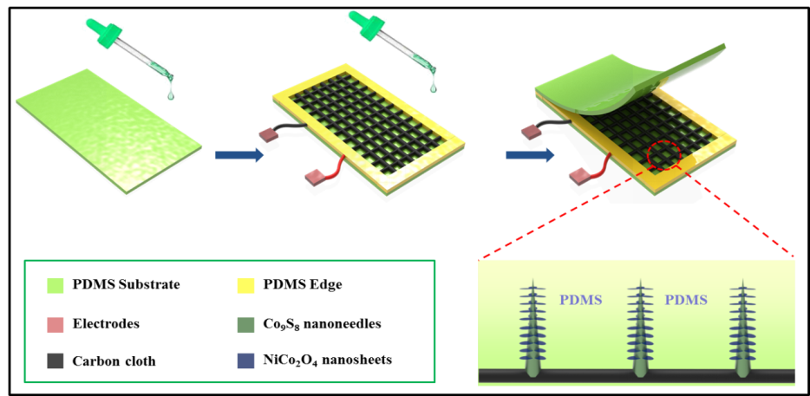
Figure 1. Schematic diagram of the flexible pressure sensor based on the hierarchical nanostructures.
References
[1] Liu, Q. et al. Hierarchically structured Co₉S₈@NiCo₂O₄ nanobrushes for high-performance flexible asymmetric supercapacitors. Chemical Engineering Journal 356, 985-993 (2019).
[2] Gao, X. Y. et al. Flexible fiber-shaped liquid/quasi-solid-state quantum dot-sensitized solar cells based on different metal sulfide counter electrodes. Appl. Phys. Lett. 113 043901 (2018).

