High-Adhesion Stretchable Electrode via Cross-Linking Intensified Electroless Deposition on Biomimetic Elastomeric Micropore Film
CY Wu*, T Zhang*, X Jun*, Y Qiu*
Name1 A. Surname1*, Name2 B. Surname2#, Name3 C. Surname3†
* State Key Laboratory of Materials Processing and Die Mould Technology, Huazhong University of Science and Technology (HUST), Wuhan 430074, China
Abstract
For the stretchable electrode, strong interface adhesion is the primary guarantee for long service life, and the maximization of tensile-limit with remarkable electrical stability can expand its usable scope. Here, a cost-effective strategy is proposed to fabricate a high-adhesion stretchable electrode. By modifying dopamine (DA) and functionalized silane on polydimethylsiloxane (PDMS) substrate in sequence before electroless deposition (ELD) process, super-high adhesion up to 3.1 MPa is achieved between PDMS substrate and silver layer, and the electrode exhibits extraordinary conductivity of 4.0 × 107 S/m. This process is also suitable for other common flexible substrates and metals. Moreover, inspired by the micro/nano structure on the surface of lotus leaf, biomimetic elastomeric micropore film (BEMF) with uniform distributed micropore is fabricated by the one-step soft lithography replication process. The electrode exhibits large tensile-limit exceeding 70% uniaxial tensile and superior electrical stability from 6.3 Ω to 11.5 Ω under 20% uniaxial tensile for more than 10000 cycles. This study seeks a promising method to manufacture stretchable electrode with high-adhesion, large tensile-limit and excellent electrical stability, showing great potential to detecting various biological signals including joint movement, surface electromyography (sEMG), etc.
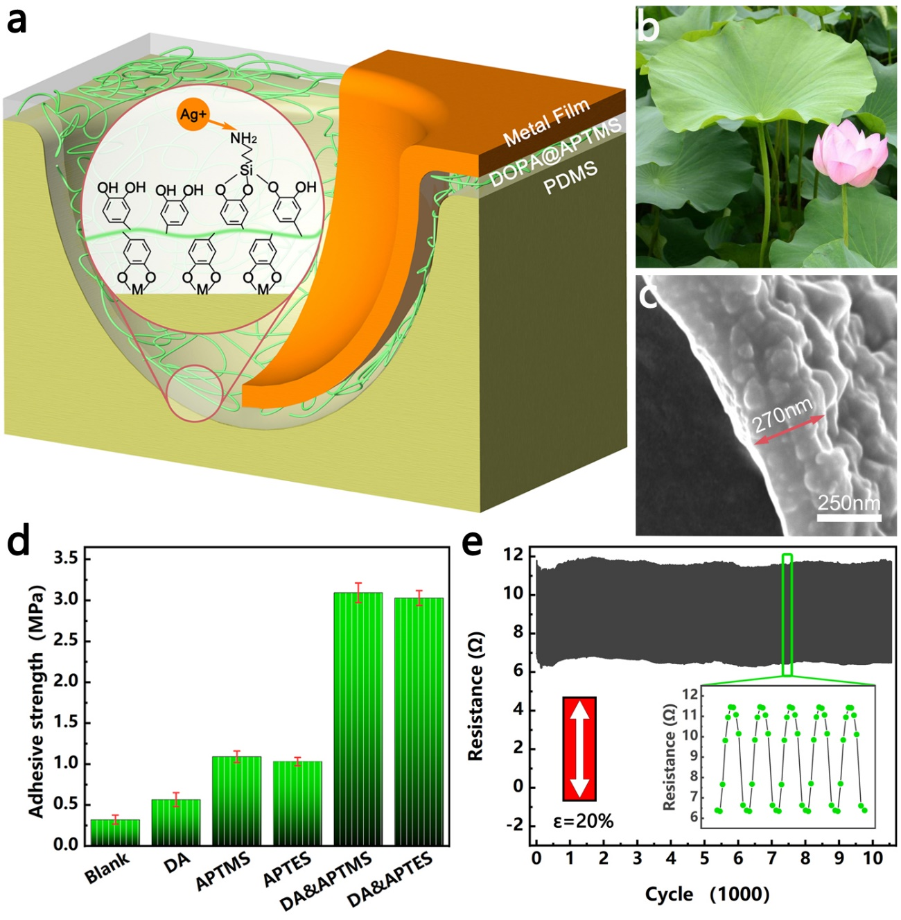
Figure: a) Schematic illustration of the chemical bonding between the silver layer and BEMF.Example of a figure and its caption. b) The inspiration for structural design comes from the uniformly distributed micron-scale protrusions on the surface of the lotus leaf. c) Cross-section of the electrode. d) The adhesion test results of the samples. e) Resistance change under 20% uniaxial tensile strain with more than 10000 cycles.

