Liquid transfer printing for carbon-based flexible electronics devices.
Xin Liu, Yihao Chen and Xue Feng *
AML, Department of Engineering Mechanics, Tsinghua University, Beijing, 100084, China,
Center for Flexible Electronics Technology, Tsinghua University, Beijing, 100084, China,
(lxin17@mails.tsinghua.edu.cn)
(chenyihao92@163.com)
(fengxue@tsinghua.edu.cn)
Abstract
In order to meet the rising needs for electronic products to integrate with various surfaces such as human body, flexible electronic technology has become an important aspect for the development of electronic industry. Flexible substrates are normally used in carbon-based devices to achieve the flexibility. After making independent different types of functional devices, a large-scale integration is extremely needed to form orderly functional system. Transfer technology provides the possibility for this integration. For instance, a PDMS stamp is normally used in the transfer process, Rogers fabricated special PDMS stamp with boundary tips which makes the printing process easier [1]. Feng uses shape memory polymer to make microstrutctures on the stamp and achieve the tranfer process with the help of temperature response [2]

However, Traditional stamp transfer involves the fracture of multi-interface[3], which leads to transfer failure due to stress concentration in high aspect ratio patterns and sharp patterns. Here we report a liquid transfer method. It makes full use of the buoyancy and surface tension of the water, leading the micro patterns to detach with the wafer automatically and be stretched by the liquid surface tension. The device remains functional after transfer printing. We transferred patterns with different Aspect ratio to confirm that there is little stress concentration caused by complicated patterns during the whole process, enabling the complex graphics to be transferred from multi-scale substrate, which is of great significance to the industrialization of flexible electronic manufacturing and the automation of transfer process.
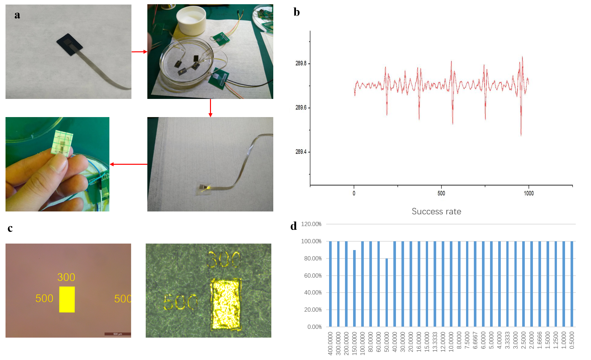
Figure 1 a.Transfer process of a strain sensor. b. Blinking response of the sensor which is attached to the eyelids. c.patterns with different aspect ratio is fabricated(left) and transferred(right). d.Transfer success rate of the patterns with different aspect ratio.

References
[1] Kim, S., et al., Microstructured elastomeric surfaces with reversible adhesion and examples of their use in deterministic assembly by transfer printing. Proc Natl Acad Sci U S A, 2010. 107(40): p. 17095-100.
[2] Huang, Y., et al., Direct Laser Writing-Based Programmable Transfer Printing via Bioinspired Shape Memory Reversible Adhesive. ACS Appl Mater Interfaces, 2016. 8(51): p. 35628-35633.
[3] Feng, X., et al., Competing fracture in kinetically controlled transfer printing. Langmuir, 2007. 23(25): p. 12555-12560.

