Wrinkled MXene Pressure Sensors for Medical Applications
Catherine Cai, Po-Yen Chen, HongLiang Ren
* Faculty of Engineering, National University of Singapore(ren@nus.edu.sg)
Abstract
The use of surgical robots in the field of minimally invasive neurosurgical procedures can offer several benefits and advantages. However, the lack of haptic interfaces hinders and limits the use of surgical robots in such procedures. One of the reasons for the lack of available haptic interfaces is the absence of force sensors that are able to meet the necessary design requirements for neurosurgical procedures. In this project, we have explored two transduction principles that force sensors can employ to measure and detect forces: capacitive and piezoresistive. While capacitive sensors appear more promising, we have found greater potential in the use of piezoresistive sensors in real life medical applications.
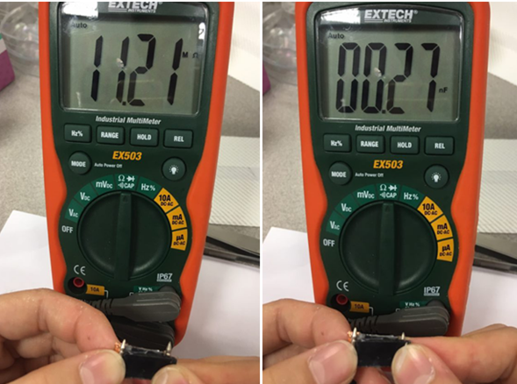
Figure 1: Sensor Resistance& capacitance under pressure

References
- Zhu, Z., Chen, P., Liu, K., & Escobedo, C. (2016). A versatile bonding method for PDMS and SU-8 and its application towards a multifunctional microfluidic device. Micromachines, 7(12), 230. doi:10.3390/mi7120230
- Zhu, Z., Geng, Y., Yuan, Z., Ren, S., Liu, M., Meng, Z., & Pan, D. (2019). A bubble-free microfluidic device for easy-to-operate immobilization, culturing and monitoring of zebrafish embryos. Micromachines, 10(3), 168. doi:10.3390/mi10030168
- Zhuo, B., Chen, S., Zhao, M., & Guo, X. (2017). High Sensitivity Flexible Capacitive Pressure Sensor Using Polydimethylsiloxane Elastomer Dielectric Layer Micro-Structured by 3-D Printed Mold. IEEE Journal of the Electron Devices Society, 5(3), 219-223. doi: 10.1109/JEDS.2017.2683558

