High-Resolution Flexible Temperature-Sensor Array Using Electrohydrodynamic (EHD) Jet Printing
Bowen Geng*, Xiaochen Ren*, Wenping Hu*
* Tianjin Key Laboratory of Molecular Optoelectronic Sciences, Tianjin University, Tianjin 300072, China (gengbowen@tju.edu.cn)
Abstract
The electro-hydrodynamic (EHD) jet printing is a promising technology because it increases the printing resolution over two orders of magnitude than traditional piezoelectric ink-jet printing methods, therefore enables the fabrication of high-resolution flexible electronics. For flexible printing devices, the temperature sensors array play an important role for their several key potential applications, such as thermal management of electronic components, human body temperature mapping and smart monitoring for logistics. In this work, we use EHD jet printing to complete the whole fabrication of an 8$×$8 temperature sensor array on one inch square flexible substrate. The single sensor device, which is shown in Figure 1, is realized by commercial Ag NPs ink and the sensing mechanism is based on measuring the temperature induced resistance change of Ag electrode. Benefited from the high-resolution of EHD jet printing, the length over width of the Ag wire could be larger than 4000, ensuring a strong reading signal even the temperature coefficient resistance (TCR) of Ag is relatively small and at the same time maintaining small sensor size. As part of the sensor array, the via-holes connect the wiring from different layers, the size of via-holes is also critical for high-resolution circuit/array fabrication, we use high-voltage of EHD jetting system to burn the through holes on the flexible substrate with hole diameter down to 5 μm, which is largely improved compared to other non-lithography based technologies. Finally, the word lines and bit lines are finished by EHD jet printing and a 50μm thick Ecoflex layer is used as the encapsulation on top. The heat transfer simulation is also studied to guide the design of temperature sensor array.

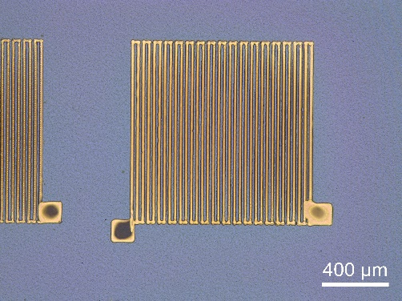
Figure 1: Temperature sensor printed by EHD jet printer.

