Self-destructing silicon nanomembrane based MOS capacitors with HfO2/Al2O3 bilayers

**Zhuofan Wang\*, Chen Liu\* #, Yuming Zhang\*, Hong-liang Lu\* , Yimen Zhang\***

\*School of Microelectronics and Key Laboratory of Wide Band-Gap Semiconductor Materials and Devices, Xidian University, 710071, China

#Corresponding author: [liuchen@xidian.edu.cn](mailto:liuchen@xidian.edu.cn)

Abstract

Transient electronics have received growing attention and have huge potential for use in bioresorbable diagnostic/therapeutic devices and eco-resorbable consumer gadgets owing to their ability to partially or completely disintegrate or disappear at controlled rates. We have reported Si nanomembrane (NM) based metal-oxide-semiconductor capacitors (MOSCAPs) with high-k bilayers on biodegradable thin film substrates of gelatin-chitosan-poly(lactic-coglycolic acid) (Gel-CS-PLGA), which can be self-destructed in a controlled timescale in biofluids. Compared with other biodegradable polymers, the Gel-CS-PLGA substrates have better biocompability and ability to tailor the dissolution rate while maintaining excellent mechanical robustness. The major procedures are summarized in Fig. 1. The biodegradable substrates are designed to vanish in several hours when immersed in 96 ℃ phosphate buffered saline (PBS) solution. The MOSCAPs with HfO2/Al2O3 bilayers initially show sharp capacitance-voltage (C-V) curves. However, the maximum capacitance obviously decrease and C-V characteristics tend to deteriorate during the first four hours immersion in 96 ℃ PBS solution. The device completely fails associated with dramatically increased leakage current at Vg=Vfb-1 V after eight hours as shown in Figs. 2 and 3. The findings suggest a promising approach to adopt atomic-layer-deposited high-k bilayers in transient Si NM based electronics.

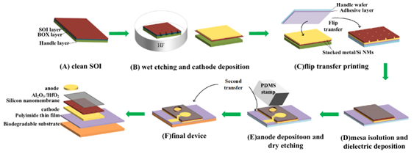

Figure 1: the illustration of key fabrication procedures for flexible Si NM based MOSCAPs on Gel-CS-PLGA substrates



Figure 2: The C-V characteristics of biodegradable MOS capacitors collected during immersion in PBS solution at pH 7.4 and 96 ℃.

 

1. (b)

Figure 3 :The accumulation capacitance (a) and leakage current density at Vg=Vfb-1 V (b) from soak tests of a device exposed to PBS solution at 96 ℃.

References

1. Suk-Won Hwang; John A. Rogers: A Physically Transient Form of Silicon Electronics. Science, Vol. 337, No. 6102, pp. 1640-1644, 2012.
2. Poluka Srilatha : Self Destructing Electronics. IOSR Journal of Electrical and Electronics Engineering, Vol. 9, No. 3, pp. 24-30, 2014.
3. Chen Liu; Zhuofan Wang: Atomic-layer-deposited HfO2/Al2O3 laminated dielectrics for bendable Si nanomembrane based MOS capacitors. Applied Physics Letters, Vol. 114, No. 14, pp. 2903, 2019.