High-Performance Flexible Tactile Sensor Enabling Intelligent Haptic Perception for Soft Prosthetic Hand
Ziwei Liang*, Jiahui Chen*, Xue Feng*
* AML, Department of Engineering Mechanics, Tsinghua University, Beijing, 100084, China,
Center for Flexible Electronics Technology, Tsinghua University, Beijing, 100084, China,
(liangzw15@mails.tsinghua.edu.cn)
(chengjh@buaa.edu.cn)
(fengxue@tsinghua.edu.cn)

Abstract
Compared to the traditional motor-driven prosthetic hand, a soft prosthetic hand (SPD) has intrisic advantages, such as kinematics dexterity and friendly extern interaction[1]. To make a SPD realize the function of a real hand, integrating flexible high-performance tactile sensors is essential. Presently, the research of flexible tactile sensors is mainly focused on increasing sensitivity, but ignores other issues, such as the complexity of arraying and the compatibility with soft actuators[2]. Here, a high-performance flexible force sensor enabling intelligent tactile perception for a SPD is reported. The flexible force sensor based on the resistance-strain effect of metal, through the effective design of 3D structure and the reasonable arrangement of the strain sensitive grid, achieves accurate measurement of normal force. Compared to other sensors, the force sensor exhibits good linearity, repeatability and accuracy, very low hysteresis, fast dynamical response (<1ms), high stability (30000 loading–unloading cycles), stable performance under high frequency (>50Hz) and is easy to be arrayed and integrated with our designed SPD.

With the sensor mounted on the surface, the SPD achieves various complicated tasks like a real hand, including feeling softness of objects and imitating the process of traditional Chinese medicine (TCM) pulse diagnosis to monitor pulse wave in radial artery. Thanks to the high linearity, fast response and accuracy of the sensor, the recorded signal could clearly and accurately reflect the data information.Finally, through a force sensor array, the SPD provids real-time force and position feedback during grabbing objects. All of these have demonstrated the promising application of our sensor and smart hand in robotics, artificial limbs and medicine.

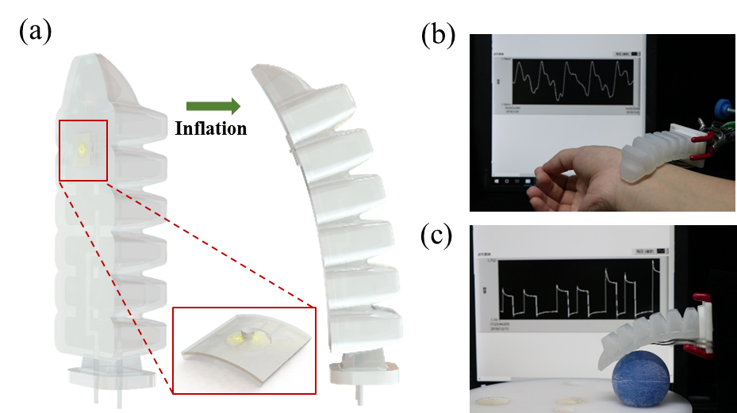
Figure 1: (a) Schematic of a soft prosthetic hand with a force sensor.(b) Detecting the pulse wave on the radial artery. (c) Feeling the softness of the objects.

References
- Daniela Rus1, Michael T. Tolley. Design, fabrication and control of soft robots. Nature, volume 521, pages 467–475, 2015.
- Huichan Zhao, Kevin O'Brien, et al. Optoelectronically innervated soft prosthetic hand via stretchable optical waveguides. Science Robotics, Vol. 1, Issue 1, eaai7529, 2016.

