Electrospun SiOC nanofibers membrane as flexible pressure sensor for harsh environment applications
Nan Wu*, Yingde Wang
College of Aerospace Science and Engineering, National University of Defense Technology, Changsha, China (lierenwn@nudt.edu.cn, wangyingde@nudt.edu.cn)
Abstract
Due to the growing demands for functional flexible electronics devices and free-standing catalyst supports, inorganic fibers with excellent flexibility and high tensile strength have gained great research interests in recent years[1]. Silicon oxycarbide (SiOC), which consists of free carbon and SiO_{x}C_{4-x} units in a fractal network structure, has been widely studied due to its excellent thermal and mechanical properties[2]. SiOC systems with various compositions and structures have been explored and applied in many novel fields, such as sensors, high-temperature microelectromechanical systems and thermal insulators[3]. Herein, flexible SiOC nanofibrous membranes were fabricated by electrospinning and following heat-treatment process. The pressure sensing performance was thoroughly investigated.
As can be seen in Figure 1a, The size of the SiOC fibers are quite uniform with an average diameter of 550 nm. SiOC nanofiber membrane exhibited excellent flexibility. No cracks were observed under bending.
The pressure sensing measurement for SiOC nanofiber membrane was done in a home-made equipment as illustrated in the inset of Figure 1b. As shown in Figure 1b, SiOC nanofiber membrane demonstrated an excellent pressure sensing property even at 500°C. The sensor response of SiOC nanofibers was 150% at 500°C, suggesting SiOC nanofiber membrane promosing materials as pressure sensors for harsh environment applications.
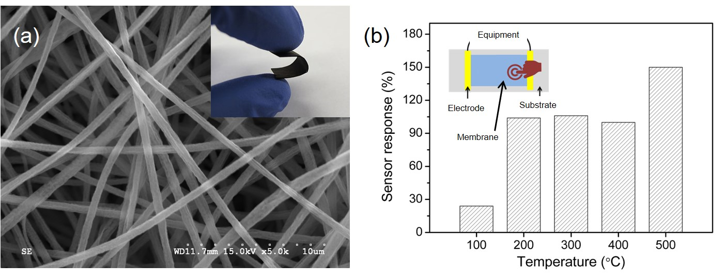
Figure 1. (a) SEM image SiOC nanofibers, inset is the digital picture of flexible SiOC nanofibers membrane; (b) Pressure sensor response of SiOC nanofibers membrane at different temperature, inset is the schemetic illustration of measurement method.
References
[1] Liu, Z.; Xu, J.; Chen, D.: Flexible electronics based on inorganic nanowires. Chem Soc
Rev, Vol 44, pp. 161–192, 2015.
[2] Lu, K.; Erb, D.; Liu, M.: Thermal stability and electrical conductivity of carbon-enriched silicon oxycarbide. J Mater Chem C, Vol 4, pp. 1829–1837, 2016.
[3] Karakuscu, A.; Ponzoni, A.; Aravind, P.R.: Gas sensing behavior of mesoporous SiOC
glasses. J Am Ceram Soc, Vol 96, pp. 2366–2369, 2013.

