Skin thermo-mechanical pain sensation for epidermal electronics
Yuhang Li, Yafei Yin
Institute of Solid Mechanics, Beihang University (BUAA), Beijing 100191, China.
Email:liyuhang@buaa.edu.cn
The epidermal electronic devices (EEDs) with distinctive adaptability have drawn much attention in many fields, such as biological monitoring and biomedicine [1,2]. Due to the tight contact between exothermic electronics and biological tissue, pain sensation is susceptive to the noxious stimulation, which is critically important for practical application. An axisymmetric analytical heat transfer model is developed to predict temperature distribution in the EED/skin system, accounting for the non-Fourier effect in skin tissues via Dual-Phase-Lag (DPL) model. The phase lag parameters in the model are obtained from the two-temperature model and then validated credibly by a series of experiments with three substrate thicknesses. Furthermore, a holistic theoretical frame is established to build a relationship between pain level and peripheral stimuli from flexible electronics. The frame consists of the thermo-mechanical model for temporal and spatial distribution of temperature and stress, Arrhenius burn model for thermal damage, modified Hodgkin–Huxley model for nociceptor conduction and gate control theory for modulation and perception. It paves the theoretical foundation for comfort design guidelines of EEDs.

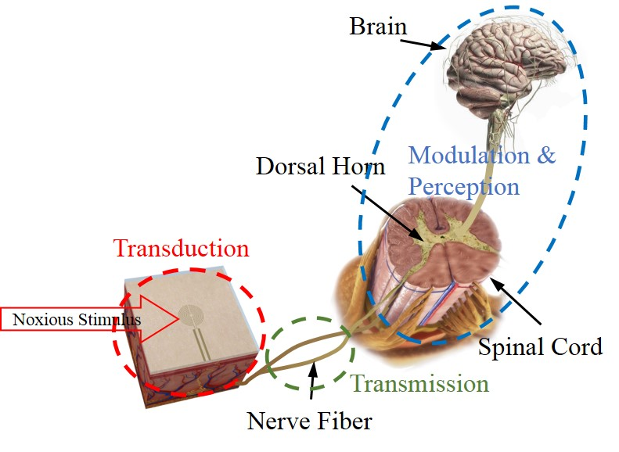
Fig1. Skin pain pathway.

- T. I. Kim, J. G. McCall, Y. H. Jung, X. Huang, E. R. Siuda, Y. Li and et al. Injectable, cellular-scale optoelectronics with applications for wireless optogenetics. Science 340, 211 (2013).
- H. Lee, T. K. Choi, Y. B. Lee, H. R. Cho, R. Ghaffari, L. Wang and et al. A graphene-based electrochemical device with thermoresponsive microneedles for diabetes monitoring and therapy. Nature Nanotechnology 11, 566 (2016).

