Highly Stable and Stretchable Conductive Films through Thermal Radiation-assisted Metal Encapsulation
Wenlong Li*, Zhiyuan Liu#, Xiaodong Chen†
* Innovative Centre for Flexible Devices (iFLEX), School of Materials Science and Engineering, Nanyang Technological University, 50 Nanyang Avenue, 639798, Singapore
Wenlong001@e.ntu.edu.sg
# Innovative Centre for Flexible Devices (iFLEX), School of Materials Science and Engineering, Nanyang Technological University, 50 Nanyang Avenue, 639798, Singapore
Liu.zhiyuan@ntu.edu.sg
† Innovative Centre for Flexible Devices (iFLEX), School of Materials Science and Engineering, Nanyang Technological University, 50 Nanyang Avenue, 639798, Singapore chenxd@ntu.edu.sg
Abstract
Stretchable conductors are the basic units of advanced flexible electronic devices, such as skin-like sensors, stretchable batteries, soft actuators and so forth.¹⁻² Current fabrication strategies are mainly focused on the stretchability of the conductor with less emphasis on the huge mismatch of the conductive material and polymeric substrate which results in stability issues during long-term usage. Here we report a new approach of thermal radiation-assisted metal encapsulation (TRAP) to construct an interlocking layer between PDMS and gold by employing semi-polymerized PDMS substrate to receive the gold atoms during thermal deposition. It can be easily fabricated in a wafer scale format in a one-step process. The stability of the stretchable conductor is significantly enhanced based on the interlocking effect of metal and polymer, with high interfacial adhesion (> 2 MPa) and cyclic stability (> 10,000 cycles). Also, the conductor possesses superior properties as high stretchability (> 130%) and large active surface area (> 5:1 effective surface area/geometrical area). As a proof of concept, both long-term implantation in animal models to monitor intramuscular electric signals and on human skin for detection of bio-signals are demonstrated. This design approach brings about a new perspective on the exploration of stretchable conductors for biomedical applications.
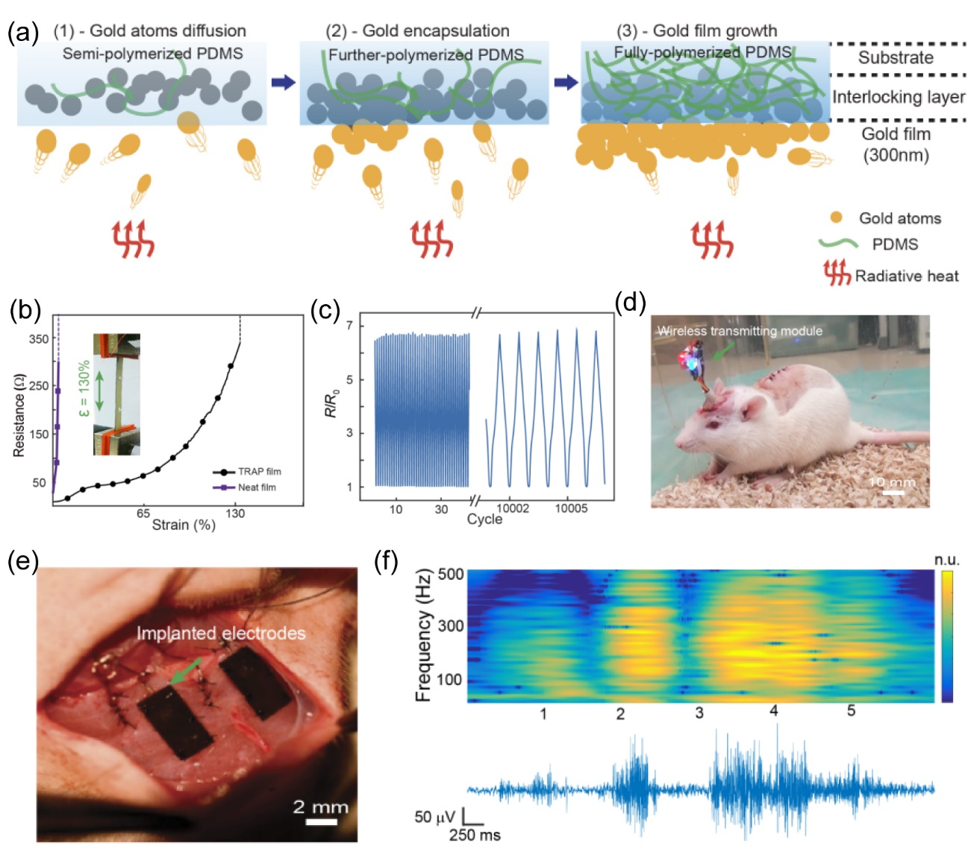
Figure 1: (a) Diagram to show the metal encapsulation behavior assisted by thermal radiation in semi-polymerized PDMS, including stage 1: metal diffusion, stage 2: continuous polymerization, and stage 3: metal encapsulation. The physical model related to the heat transfer is illustrated in Figure S1, and the detailed analysis of the heat transfer is in Supporting Note 1 and 2. (b) Resistance change of the TRAP film and neat film. It is out of the measurement range indicating the gold film break. Inset presents the optical image of the testing process. (c) Resistance change under cyclic tensile strain to show the stability of the stretchable conductor. (d) Images to show long-term implantation testing of animal model for intramuscular monitoring. Wireless data-acquisition system integrated with the rat, nerve bundle transplantation process and (e) our novel electrodes applied to detect the signal. (f) Intramuscular EMG signals detected and related spectral analysis.

References
1. Bao, Z.; Chen, X., Flexible and Stretchable Devices. Adv. Mater. 2016, 28 (22), 4177-4179.
2. Lin, S.; Yuk, H.; Zhang, T.; Parada, G. A.; Koo, H.; Yu, C.; Zhao, X., Stretchable Hydrogel Electronics and Devices. Adv. Mater. 2016, 28 (22), 4497-4505.

