Human Skin-Inspired Electronic Sensor Skin with Electromagnetic Interference Protection
Junhong Pu, Mingbo Yang, Wei Yang*
State Key Laboratory of Polymer Materials Engineering, College of Polymer Science and Engineering, Sichuan University, Chengdu, 610065, People’s Republic of China. (Puzzihong@outlook.com)
Abstract
Increasingly serious electromagnetic radiation pollution puts higher demands on wearable devices.
Sensor skin capable of shielding electromagnetic radiation can provide extra protection in emerging fields such as electronic skins, robotics, and artificial intelligence, but combining the sensation and electromagnetic shielding performance together remains a great challenge. Here, inspired by the structure and functions of the human skin, a multifunctional electronic skin (M-E-skin) with both tactile sensing and electromagnetic radiation shielding functions is proposed. The tactile sensing of human skin is mimicked with irregular dermislike rough surfaces, and the electromagnetic shielding performance not available on natural skin is introduced by mimicking the ultraviolet driving radiation absorption of melanin in epidermis. The M- E-skin shows superior sensitivity (9.8×10⁴ kPa⁻¹ for the pressure range 0−0.2 kPa and 3.5×10³ kPa⁻¹ within 0.2−20 kPa), broad operating range (0−20 kPa), fast response and relaxation times (<62.5 ms), great pressuring-relaxing stability (10 kPa, 1000 cycles), low operating voltage (0.1 V), low power consumption (1.5 nW), and low detection limit (5 Pa). Besides, a broad range of electromagnetic wave (0.5−7.5 GHz) is shielded more than 99.66% by the ME-skin. This work holds great potential to enlarge the application scope of current electronic skins.

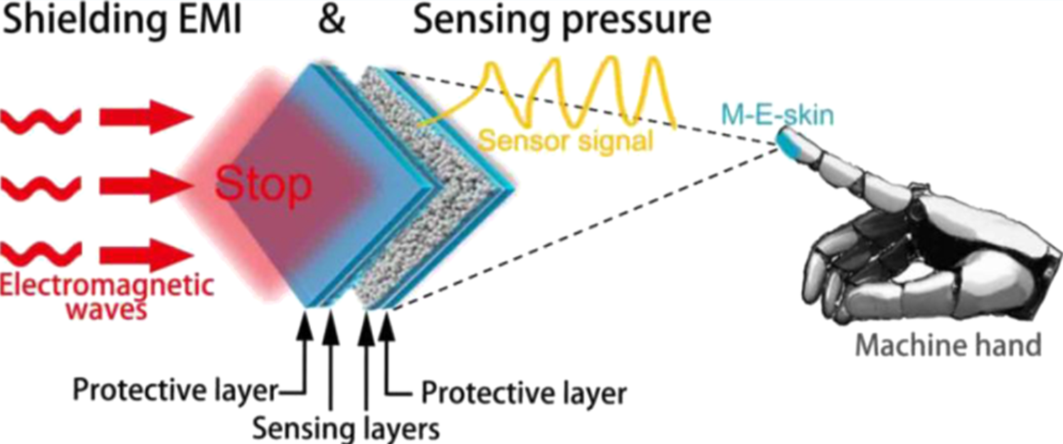
Figure 1: A multifunctional electronic skin (M-E-skin) is fabricated by mimicking the structure and functions of human skin. The M-E-skin is capable of electromagnetic radiation shielding and tactile sensing.

