Highly-nonlinear flexible threshold switch device for the selection of sensory arrays
Ming Wang*, Xiaodong Chen†
* Innovative Centre for Flexible Devices (iFLEX), School of Materials Science and Engineering, Nanyang Technological University, 50 Nanyang Avenue, 639798, Singapore
wang.ming@ntu.edu.sg

† Innovative Centre for Flexible Devices (iFLEX), School of Materials Science and Engineering, Nanyang Technological University, 50 Nanyang Avenue, 639798, Singapore chenxd@ntu.edu.sg

Abstract
Electronic switches are essential building blocks for large-scale integration of high-performance electronic and optoelectronic components. The increasing need for healthcare, wearables, and soft robotics has fuelled the rapid growth of interest in two-terminal electronic switch with the bidirectional, nonlinear, and flexible characteristics. However, existing flexible electronic switch couldn’t fulfill these requirements due to their intrinsic rigidity or high temperature process. Here we report a high-nonlinear flexible electronic switch by utilizing that nano-contact effect induced threshold switching effect in elastic nanocomposite dielectric. The two-terminal electronic switch shows bidirectional switching characteristics with super-nonlinearity (1010), high ON-state current (500 µA), and robust mechanical flexibility. Further, a fully integrated flexible threshold electronic switch-based matrix backplane was successfully demonstrated for e-skin application. These results enable a new way to pursue high nonlinear, mechanically flexible, even stretchable electronic switch for large-scale integration of flexible electronic and optoelectronic system.

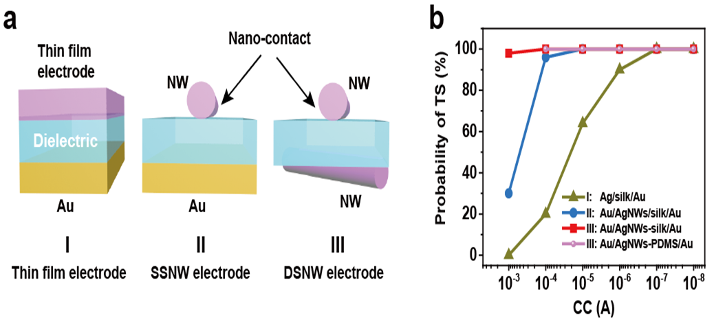
Figure 1. Illustration of nano-contact strategy. (a) Schematic of the configuration of threshold switching devices with different contact morphology. I: device with a thin-film electrode, II: device with a single-side nanowire (SSNW) electrode configuration, III: device with a double-side nanowire (DSNW) electrode configuration. b, Probability of TS as a function of the CC for devices I, II, III.

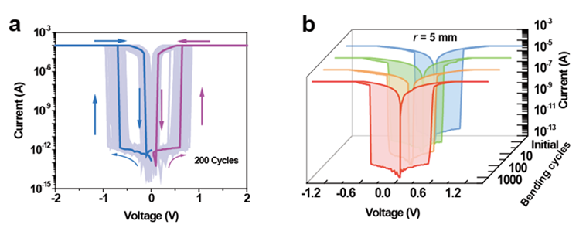
Figure 2. Electrical characteristics of Au/AgNWs-PDMS/Au threshold switching device under flat state (a) and bending state (b).

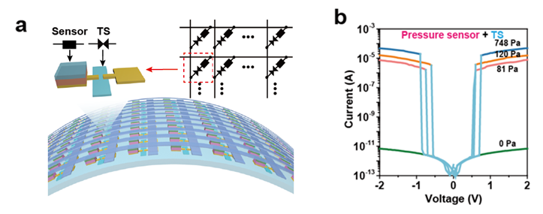
Figure 3. Configuration (a) and measurement results (b) of the integrated crossbar array of sensors based on the two-terminal flexible threshold switching devices.

