Electrospun Nanofibers for Powering Flexible and Wearable Electronic Devices for Human Health Monitoring
Yichun Ding*,†, Wenhui Xu,# Zhengtao Zhu†
* Fujian Institute of Research on the Structure of Matter, Chinese Academy of Sciences, Fuzhou, Fujian 350002, China (ycding@fjirsm.ac.cn)
# School of Pharmacy, Jiangxi University of Traditional Chinese Medicine, Nanchang, Jiangxi 330004, China (wenhuixu19@126.com)
† Biomedical Engineering Program, Department of Chemistry and Applied Biological Sciences, South Dakota School of Mines & Technology, Rapid City, SD 57701, USA (zhengtao.zhu@sdsmt.edu)
Abstract
The past few years have witnessed the ever-increasing development of flexible and wearable electronics, which have great potentials for human health monitoring, artificial intelligence, and Internet of Things (IoT) [1]. The flexible and wearable healthcare monitoring system can provide real-time monitoring of human body activities/conditions thus gathering timely information about human health status. A fully functional wearable sensing system not only requires active sensors but also needs other components including power supply, conductor, data acquisition, and signal processing modules, etc. While substantial achievements have been progressively made due to the continued innovation of materials and fabrication technologies, advanced materials and high-performance devices are still eagerly desired for paving the way of flexible electronics to practical applications.

In recent years, we have been exploring electrospun nanofibers as a key component in flexible and wearable electronic devices such as flexible sensors, conductors, and power supply devices (Figure 1). Electrospun nanofibers, produced by electrospinning technique, represents a class of promising nanomaterials for various applications in biomedical engineering, microelectronics, energy storage and conversion devices, and environmental remediation, owing to their advantageous properties of ultrasmall diameter, large surface area, scalable fabrication, and facile functionalization [2]. Using electrospun carbon nanofiber as a piezoresistive element, we have demonstrated highly stretchable strain sensors by embedding freestanding electrospun carbon nanofibrous mat in an elastomer for human motion monitoring [3]. We also prepared a three-dimensional (3D) conductive sponge by freeze-drying of the building blocks of shortened electrospun nanofibers, which was then used for assembling a highly compressible tactile sensor for electronic skin application [4]. To develop a stretchable and wearable conductive textile on a large scale, we combined electrospinning of an elastomer (e.g., polyurethane) with dip coating technique. The fabricated conductive fibrous nonwoven (PEDOT:PSS@PU) could be used directly or integrated into cloth for wearable conductor applications [5]. We are currently developing flexible power supply devices (e.g., battery, nanogenerator) by adopting electrospun nanofibers as an active material or substrate. Herein, we present our results as well as on-going projects regarding electrospun nanofibers for flexible devices. We anticipate that the powerful tool of electrospinning technique will stimulate development of flexible and wearable electronics and potentially a fully funcational wearable electronic system can be achieved using all-electrospun nanofibers-based devices.
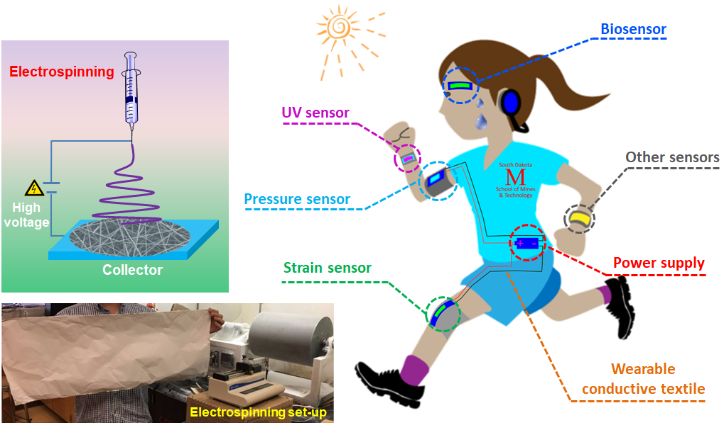
Figure 1: Electrospining setup and application of electrospun nanofibers for various flexible and werable electronic devices.

References
- Ding, Y.C.; Xu, T.; Onyilagha, O.; Fong, H.; Zhu, Z.T.: Recent Advances in Flexible and Wearable Pressure Sensors Based on Piezoresistive 3D Monolithic Conductive Sponges. ACS Applied Materials & Interfaces, Vol. 11, No. 7, pp. 6685-6704, 2019.
- Ding, Y.C.; Hou, H.Q.; Zhao, Y.; Zhu, Z.T.; Fong, H.: Electrospun Polyimide Nanofibers and Their Application. Progress in Polymer Science, Vol. 61, pp. 67-103, 2016.
- Ding, Y.C.; Yang, J.; Tolle, C.R.; Zhu, Z.T.: A Highly Stretchable Strain Sensor Based on Electrospun Carbon Nanofibers for Human Motion Monitoring. RSC Advances, Vol. 6, No. 83, pp. 79114-79120, 2016.
- Xu, T.; Ding, Y.C.; Wang, Z.; Zhao, Y.; Wu, W.D.; Fong, H.; Zhu, Z.T.: Three-Dimensional and Ultralight Sponges with Tunable Conductivity Assembled from Electrospun Nanofibers for A Highly Sensitive Tactile Pressure Sensor. Journal of Materials Chemistry C, Vol. 5, No. 39, pp. 10288-10294, 2017.
- Ding, Y.C.; Xu, W.H.; Wang, W.Y.; Fong, H.; Zhu, Z.T.: Scalable and Facile Preparation of Highly Stretchable Electrospun PEDOT:PSS@PU Fibrous Nonwovens towards Wearable Conductive Textile Applications. ACS Applied Materials & Interfaces, Vol. 9, No. 35, pp. 30014-30023, 2017.

