Single-use neurotransmitter sensor by 3D laser-scribed graphene grass
Guangyuan Xu*, #, †, Paul A. Kilmartin#, Jadranka Travas-Sejdic#, †, Xue Feng*
* Centre for flexible electronic technology, Department of Engineering Mechanics, Tsinghua University, Beijing 100084, China
# Polymer Electronic Research Centre, School of Chemical Sciences, The University of Auckland, Auckland 1010, New Zealand
† MacDiarmid Institute for Advanced Materials and Nanotechnology, Wellington 6140, New Zealand
Abstract
A range of novel carbon nanomaterials, including 0D fullerene, 1D carbon nanotubes, 1D carbon nanofibers, 2D graphene and graphene oxide, and 3D carbon aerogels, has attracted considerable interest and investments from across the scientific society ¹. Due to their excellent performance, the carbon nanomaterials have contributed significantly towards the development of miniaturized integrated point-of-care biological and chemical sensors. Graphene, as a sensing and signal transducing material is well established, and the recently developed method of “laser scribing” has already been demonstrated as a facile approach for manufacturing graphene electronics for highly selective, sensitive biological sensing devices ²⁻³. Inspired by the different morphologies and derivatives of the carbon nanomaterials that have been fabricated, including carbon nanowalls, graphene nanoribbons, vertically aligned CNTs and laser induced graphene fibers, we first fabricated laser scribed graphene grass (LSG grass) with a novel 3D vertical aligned tree-like morphology ⁴. We have then used the LSG grass in the application of dopamine detection by means of cyclic voltammetry (CV) and differential pulse voltammetry (DPV). The electrochemical anodic peaks of dopamine (DA), ascorbic acid (AA) and uric acid (UA) using LSG grass electrode were investigated, where UA and AA were considered as common interferences. The sensitivity of LSG grass for DA sensing was highly improved compared to normal LSG. The fabricated LSG grass sensor exhibits a sensitivity of 0.299 µA/µΜ and detection limit of 1 µΜ. The outstanding performance for dopamine detection using LSG grass is a reflection of the promising future of carbon nanomaterials with interesting high surface area morphologies.

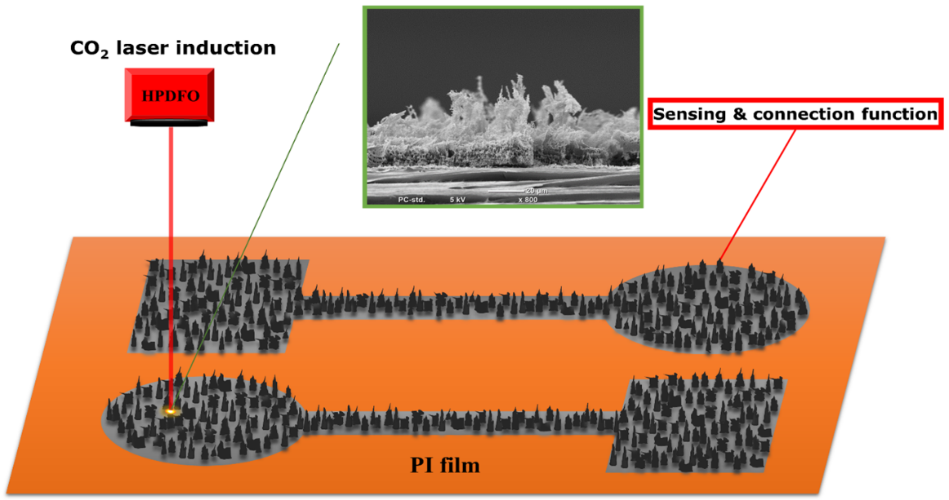
Figure 1: Schemetic representation of 3D LSG grass fabrication ⁴.

References
1. Xu, G.; Malmström, J.; Edmonds, N.; Broderick, N.; Travas-Sejdic, J.; Jin, J., Investigation of the reduction of graphene oxide by lithium triethylborohydride. Journal of Nanomaterials 2016, 2016, 16.
2. Xu, G.; Jarjes, Z. A.; Desprez, V.; Kilmartin, P. A.; Travas-Sejdic, J., Sensitive, selective, disposable electrochemical dopamine sensor based on PEDOT-modified laser scribed graphene. Biosens Bioelectron 2018, 107, 184-191.
3. Xu, G.; Aydemir, N.; Kilmartin, P. A.; Travas-Sejdic, J., Direct laser scribed graphene/PVDF-HFP composite electrodes with improved mechanical water wear and their electrochemistry. Applied Materials Today 2017, 8, 35-43.
4. Xu, G.; Jarjes, Z. A.; Wang, H.-W.; Phillips, A. R. J.; Kilmartin, P. A.; Travas-Sejdic, J., Detection of Neurotransmitters by Three-Dimensional Laser-Scribed Graphene Grass Electrodes. ACS Applied Materials & Interfaces 2018, 10 (49), 42136-42145.

