Strain-Insensitive and Durable Stretchable Pressure Sensors for Human-Machine Interfaces
Zhe Yu#,†,†, Yiwei Liu#,†, Jie Shang#,†, Run-Wei Li#,†
*CAS Key Laboratory of Magnetic Materials and Devices, Ningbo Institute of Materials Technology and Engineering, Chinese Academy of Sciences, Ningbo, 315201, P. R. China
#Zhejiang Province Key Laboratory of Magnetic Materials and Application Technology, CAS Ningbo Institute of Materials Technology and Engineering, Ningbo, 315201, P. R. China
†University of Chinese Academy of Sciences, 19 A Yuquan Rd, Shijingshan District, Beijing, 100049, P. R. China
(yuzhe@nimte.ac.cn; shangjie@nimte.ac.cn; runweili@nimte.ac.cn)

Abstract
With the development of stretchable sensors, the flexible pressure sensors are expected to be soft and stretchable as human skin. The intrinsically stretchable composites, composed of conductive particle fillers and elastic polymer matrixes, are ideal pressure-sensitive materials for stretchable pressure sensors. However, the pressure sensors based on pressure-sensitive composites are sensitive to stretching strain and not durable under repeated stretching.^{[1]} Because the random distribution of fillers in matrixes will change by strain, and the polymer chains will creep while repeated stretching.

Here, the magnetic particle with nanostructured spines (Figure 1a) and polyurethane (PU) with non-plane rings are chose as filler and matrix, respectively. To the filler, it will form ordered distribution with vertical aligned columns by applying magnetic field to weaken the effect of strain (Figure 1b), and its spines increase the sensitivity of pressure.^{[2]} To the matrix, PU can store and release strain energy by the isomeric transformation of non-planer rings to ensure the durability of composite (Figure 1c). ^{[3]}

Therefore, the stretchable pressure sensor based on our composite exhibits strain-insensitivity and great durability. It remains a high sensitivity (> 10 kPa⁻¹) while stretching to 400% stain (Figure 1d). After repeated stretching for 10,000 cycles, the sensor reproduces the original performance well. We successfully demonstrated the sensor array to detect finger pressure during repeated movement, which shows the potential of our stretchable pressure sensor in human-machine Interfaces.
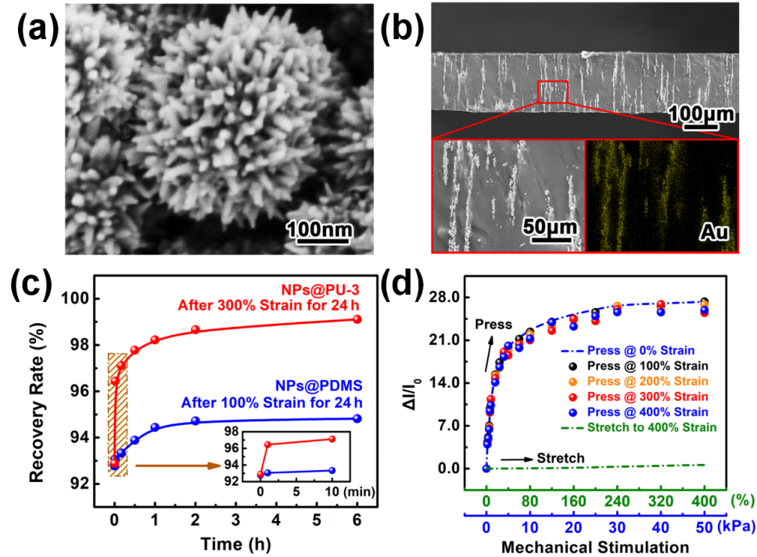
Figure 1: (a) Scanning electron microscopic image of magnetic Ni nanoparticle with Au nanostructured spines. (b) Scanning electron microscopic cross-sectional image of prepared composite. (c) Recovery rate of composites with different matrixes after stretching for 24h. (d) Electrical responses of prepared pressure-sensitive composite at different mechanical stimulation.

References
- Chortos, A.; Liu, J.; Bao Z.: Pursuing Prosthetic Electronic Skin. Nature Materials, Vol. 15, No. 9, pp. 937-950, 2016.
- Yin, B.; Liu, X.; Gao, H.; Fu, T.; Yao, J.: Bioinspired and Bristled Microparticles for Ultrasensitive Pressure and Strain Sensors. Nature Communications, Vol. 9, No. 9, 5161, 2018.
- Marszalek, P.E.; Oberhauser, A.F.; Pang Y.-P.; Fernandez J.M.: Polysaccharide Elasticity Governed by Chair-Boat Transitions of the Glucopyranose Ring. Nature, Vol. 396, No. 6712, pp. 661-664, 1998.

