Wide Range and Low Detection Limit Flexible Magnetic Sensors for Electronic Skin
Shengbin Li *#†, Yiwei Liu*#, Run-Wei Li*#†
* CAS Key Laboratory of Magnetic Materials and Devices, Ningbo Institute of Materials Technology and Engineering Chinese Academy of Sciences, Ningbo, 315201, P. R. China (lishengbin@nimte.ac.cn; liuyw@nimte.ac.cn; runweili@nimte.ac.cn)
# Zhejiang Province Key Laboratory of Magnetic Materials and Application Technology, Ningbo Institute of Materials Technology and Engineering Chinese Academy of Sciences, Ningbo, 315201, P. R. China
† School of Future Technology, University of Chinese Academy of Sciences, Beijing, 100049, P. R. China
Abstract
Electronic skins (e-skins) which are conformably situated on biological tissue, readily following all its natural motions and distortions have shown broad application prospects in consumer electronics, WIT120, and other fields. Flexible magnetic sensors are an important component of e-skins, they provide the " sixth sense " -non-contact detection of static or dynamic magnetic fields. But the simultaneous realization of high flexibility, low detection limit, and wide range has become a core problem of current magnetic sensors used in e-skins. Amorphous wires have many special effects like giant magnetic impedance effect (GMI) and giant stress impedance effect (GSI). In this work, we have combined GMI and GSI effects in a single device, to realize low detection limit and wide range simultaneously. The amorphous wires and magnetic particle are encapsulated in Eco-flex elastomer. GMI effect of amorphous wires works well at the low magnetic field but at higher magnetic field values, GMI effect saturates and elastomer starts deforming due to the interaction between the magnetic field and magnetic particles inside. Elastomer deformation also drives the amorphous wire to deform, thus generating stress and continuously changing its impedance. By this method, we can measure the magnetic field from 1nT to 0.4T in a single device. The current sensor can also stretch upto 15% perpendicular to the amorphous wire, thus can be applied to navigation, motion tracking in robotics and regenerative medicine.
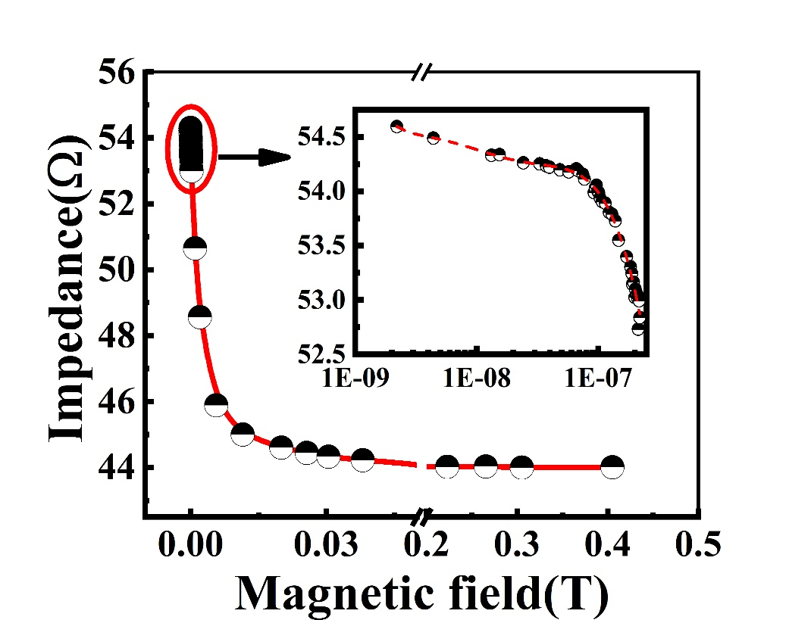
Figure1: The response of the magnetic sensor on the magnetic field
References
- Denys Makarov; Michael Melzer; Daniil Karnaushenko; Oliver G. Schmidt: Shapeable magnetoelectronics. Applied Physics Reviews, Vol 3, pp. 011102, 2016.
- Manh-Huong Phan; Hua-Xin Peng: Giant magnetoimpedance materials: Fundamentals and applications. Progress in Materials Science, Vol 53, No. 2, pp. 323-420, 2008.
- Gilbert Santiago Cañón Bermúdez, Dmitriy D. Karnaushenko, Daniil Karnaushenko, Ana Lebanov, Lothar Bischoff, Martin Kaltenbrunner, Jürgen Fassbender, Oliver G. Schmidt, Denys Makarov: Magnetosensitive e-skins with directional perception for augmented reality. Science Advances, Vol 4, pp. eeao2623, 2018
- Gilbert Santiago Cañón Bermúdez, Hagen Fuchs, Lothar Bischoff, Jürgen Fassbender, Denys Makarov: Electronic-skin compasses for geomagnetic fielddriven artificial magnetoreception and interactive electronics. Nature Electronics, Vol. 1, No. 11, pp. 589-595, 2018

