Flexible Tactile Sensors having Tunable Properties with Magnetically Grown Dielectric Interface
Waqas Asghar *#†, Yiwei Liu*#, Runwei Li*#
* CAS Key Laboratory of Magnetic Materials and Devices, Ningbo Institute of Materials Technology and Engineering Chinese Academy of Sciences, Ningbo, 315201, P. R. China (waqas@nimte.ac.cn; liuyw@nimte.ac.cn; runweili@nimte.ac.cn)
# Zhejiang Province Key Laboratory of Magnetic Materials and Application Technology, Ningbo Institute of Materials Technology and Engineering Chinese Academy of Sciences, Ningbo, 315201, P. R. China
† University of Chinese Academy of Sciences, Beijing, 100049, P. R. China
Abstract
Highly sensitive flexible tactile sensors fabricated in a low cost and efficient way are crucial for future electronic skins (e-skins). Generally, high performance capacitive tactile sensors are obtained by micropatterning their dielectric layers, using expensive photolithography and natural molds based conventional techniques. Herein, we report a novel strategy for the microstructuration of dielectric layer based on magnetic field induced dielectric interface. Microneedles based sensor’s dielectric interface is obtained by varying nanoparticles concentration (mixed in PDMS) and magnitude of vertical magnetic field, applied during curing. Sensor containing dielectric layer prepared at 1:1 (PDMS : nanoparticles) and 170 mT curing magnetic field has shown high sensitivity of 0.15 kPa-1 , fast response time of 41 ms. Young’s Modulus tests and SEM analysis confirms that sparse and high-aspect-ratio microneedles having lowest nanoparticles concentration are critical to achieve high sensitivity, low limit of detection, and fast response to external stimulus. Moreover, placing sensor in external magnetic field, affects its sensitivity which make this sensor unique from other sensors. More importantly, the currently developed flexible tactile sensors are potentially useful in intelligent soft robots, health monitoring, and motion detection.
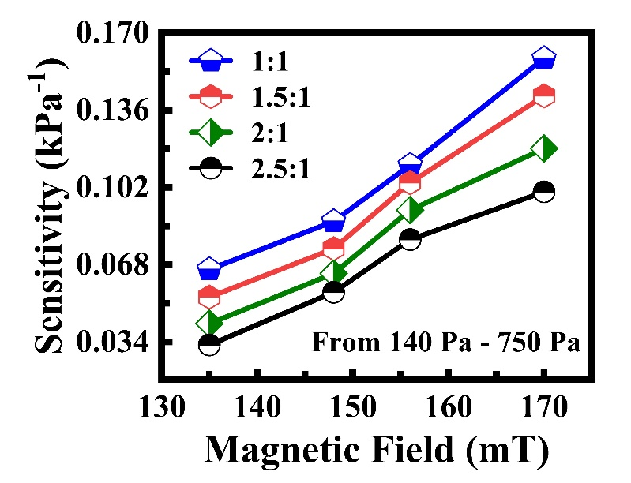[1-4]

References
1. Wan, Y., et al., A Highly Sensitive Flexible Capacitive Tactile Sensor with Sparse and High‐Aspect‐Ratio Microstructures. Advanced Electronic Materials, 2018. 4(4): p. 1700586.
2. dos Santos, A., et al., Piezoresistive E‐Skin Sensors Produced with Laser Engraved Molds. Advanced Electronic Materials, 2018. 4(9): p. 1800182.
3. Qiu, Z., et al., Ionic skin with biomimetic dielectric layer templated from calathea zebrine leaf. Advanced Functional Materials, 2018. 28(37): p. 1802343.
4. Cho, S.H., et al., Micropatterned pyramidal ionic gels for sensing broad-range pressures with high sensitivity. ACS applied materials & interfaces, 2017. 9(11): p. 10128-10135.

