Full Printed Flexible Capacitive Sensor for Non-contact

Respiratory Monitoring
Yanan Zheng*#†, Zhe Yu*#†, Yiwei Liu*#, Shang Jie*#, Run-Wei Li*#
* CAS Key Laboratory of Magnetic Materials and Devices, Ningbo Institute of Materials Technology and Engineering, Chinese Academy of Sciences, Ningbo, 315201, P. R. China
# Zhejiang Province Key Laboratory of Magnetic Materials and Application Technology, Ningbo Institute of Materials Technology and Engineering, Chinese Academy of Sciences, Ningbo, 315201, P. R. China
† University of Chinese Academy of Sciences, 19 A Yuquan Rd, Shijingshan District, Beijing, 100049, P. R. China
(zhengyanan@nimte.ac.cn; shangjie@nimte.ac.cn; runweili@nimte.ac.cn)
Abstract
Respiration is an important indicator of human health. Unusual respiratory patterns are a critical symptom of many diseases, such as sleep apnea hypopnea syndrome (SAHS), asthma, chronic obstructive pulmonary disease (CODP) and anemia.^{[1]} At present, the detection of respiration mainly uses a resistive strain sensor. The sensor senses respiration through deformation, so it must be closely attached to the human skin, which is not only uncomfortable to wear, but also prone to skin irritation.^{[2, 3]} In this paper, a highly sensitive capacitive sensor is prepared by full printed method. The sensor can be directly printed on the clothes, and the non-contact detection of respiratory can be realized by detecting small changes of the bioelectric field generated by the human body. ^{[4]} The maximum detection distance is 10 cm, and the relative change rate of capacitance caused by respiratory exceeds 0.2% when the detection distance is 5 cm. In short, this paper reports a new and promising sensor device for long real-time detection of respiratory.

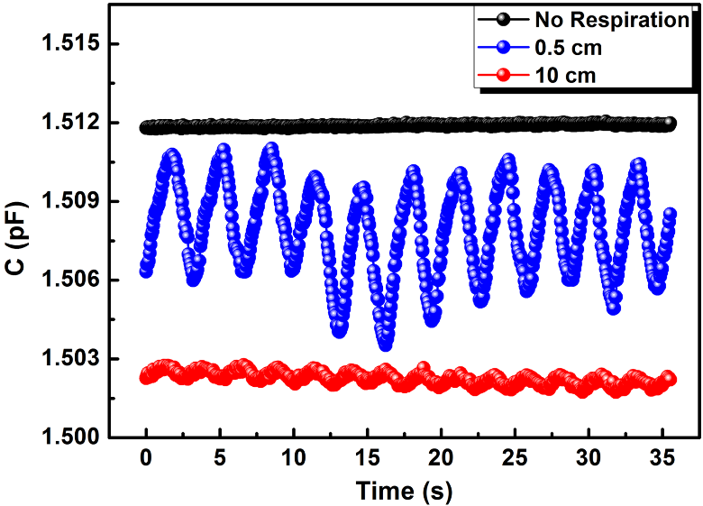
Figure 1: Respiratory signals at different distances from the human body.

References
- Yan Liu; Hai Wang: Flexible, Stretchable Sensors for Wearable Health Monitoring: Sensing Mechanisms, Materials, Fabrication Strategies and Features. Sensors, Vol. 18, No. 2, pp. 645, 2018.
- Chunya Wang; Yingying Zhang: Carbonized Silk Fabric for Ultrastretchable, Highly Sensitive, and Wearable Strain Sensors. Advanced Materials, Vol. 28, No. 31, pp. 6640-6648, 2016.
- Youngoh Lee; Hyunhyub Ko: Flexible Ferroelectric Sensors with Ultrahigh Pressure Sensitivity and Linear Response over Exceptionally Broad Pressure Range. ACS Nano, Vol. 12, No. 4, pp. 4045-4054, 2018.
- Shanshan Yao; Yong Zhu: Wearable multifunctional sensors using printed stretchable conductors made of silver nanowires. Nanoscale, Vol. 6, pp. 2345-2352, 2014.

